The project that my group and I will be working on is Redesigning ATMs (Automatic Teller Machines). I assumed that a user is purchasing goods at some sort of physical marketplace and doesn’t have a form of payment available. The first low level exercise I chose was the naturalistic observation by watching people while they were accessing ATMs. For the most part, about 80%, people were withdrawing money. I’m not entirely sure if any other processes took place. The other 20% did not get money out of the machine, but did always receive a receipt at the end of their transaction(s). For this, I would assume they are checking their account balance or performing some other transaction besides the norm of withdrawing money. I also noticed a discreet sequence of events. The user would approach the machine, insert their debit card, pause while reading the screen, punch in a code followed by enter, and then choose their options. Unfortunately, I didn’t ask anyone to think out loud while at the ATM.

The second method I chose was the one of participant observation. I did this by visiting as many ATM’s as possible. I found some areas that were insightful. The interface constantly changed and I never saw the same one twice. Many ATM’s offer a “Quick Cash” function. It will give you an amount that is predetermined by the owner and skip some of the normal questions such as which account you would like to pull from. Most ATM’s that had a quick cash function had a value of $40 for this, but some went up to $300 or had a value between $40 and $300. When doing so, it always came from checking. Almost all ATM’s charge a service fee if outside of your banking institution. My bank is a federal credit union. With that, I found that the fee was waived at other federal credit union ATM’s. To avoid bias, I also went to other ATM’s where I was required to pay a fee. Some of the ATM’s were walk up while some were drive up. The drive up ATM’s are typically at banks, but I did see two that were in parking lots of grocery stores. At no point did I see any possibility of withdrawing money or checking my balance without my debit card.

The final exercise I chose was to analyze current interfaces. I can use much of the information I gathered from my first and second analyzations, along with some more detail. Typically, all ATM’s have a keypad such as in **Image 1** and a slot to insert a debit or credit card. A few of the interfaces were also touchscreen. Some of the touchscreen interfaces still had a keypad and some did not. If the screen was not a touchscreen such as in **Image 2**, then there were usually 8 buttons around the screen to allow additional user interaction such as selecting which account to withdrawal from or if they wanted a receipt or not. Most of the time, the pattern at the interface was the same when a I would approach it to perform a task. I’ve described these in **Figure 1**.

To build off of my analyzation of current interfaces, I also created a survey. The original survey can be seen at [goo.gl/forms/RDGdHamLgjgjSFTE2](https://goo.gl/forms/RDGdHamLgjgjSFTE2). The results can be seen at <https://goo.gl/ZucWgH>. As it turns out, everyone who took the survey uses ATM’s (**Figure 2**). The survey had 9 other questions and was geared towards their typical usage of ATM’s and what they like or don’t like about them. I also asked if they know their account number and/or routing number. These are important to my redesign as they could be very key in helping a user access their account at an ATM without using their debit card. About half of the responses knew their account numbers but only about a third know their routing number (**Figure 3**). I asked what users like and don’t like about ATM’s. They seemed to use ATM’s for the convenience as they can use it outside of bank hours and it’s easier than having to go in and fill out forms. Also, they would avoid ATM’s if they were in an insecure or unsafe location for fear of getting robbed or even hurt or killed. Furthermore, additional fees and location of the ATM were a consistent problem among the users that took the survey.

For my data inventory, I can say that the users are anyone with a bank and access to an ATM. They can be any age or gender, but their range of expertise in using an ATM can vary. Because I posted the survey on Facebook, GT Slack channels, and other places, the users could be anywhere in the world, but are typically within the United States. The context of the data gathering task was to determine typical ATM usage and if they knew some required personal information. Their goals were to use specific methods of ATM’s in order to deposit money, check their balance, withdrawal money, and pay bills. Considering that most of the answers for the question “Please describe why you would avoid using an ATM”, they need safer and easier ways to access ATM’s without being charged fees. Their tasks are to go shopping for goods, pay for services, and spend money on other things. Their subtasks would be to get that money in an easy and quick manner.

My requirements from the data inventory are fairly simple. The redesign of the ATM interface needs to be safe and secure. I need to ensure that skimming devices or other outside sources can’t be attached to the new interface that allows people to access their account without their debit card. It needs to be easy to understand and use as well. The users will need to be told exactly what is expected when they step up to the new design. The steps through the new process shouldn’t be much different than what has already been incorporated in most ATM’s.

The next iteration should be to assess if people would like a functionality that would allow them to access their account through an ATM without requiring them to have their debit card. If so, I need to find out if they would be willing to memorize personal information such as their bank’s routing number. I will also need to find a decent process in order to let users access their accounts through an ATM. What personal information should be collected? How will the ATM keep security at the same level as it was before?

*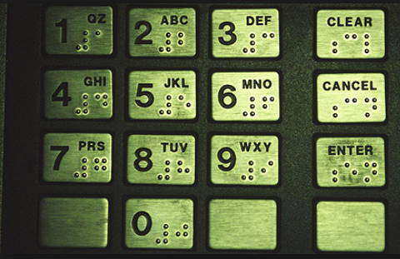  
Image 1: Typical Keypad*

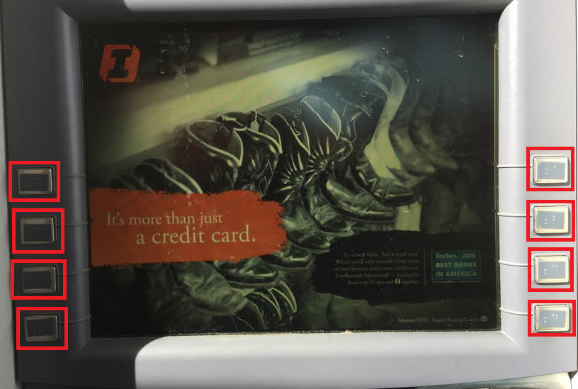

*Image 2: Typical non-touchscreen ATM with additional buttons*

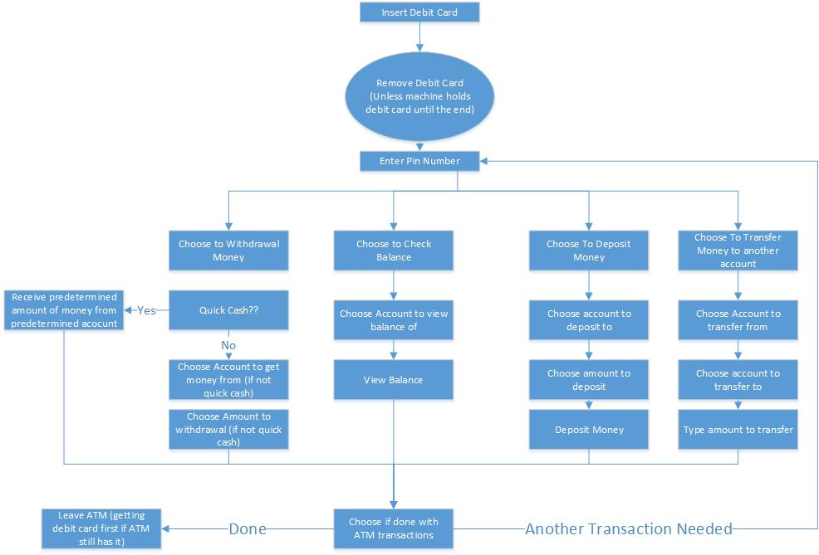

*Figure 1: Typical ATM Processes*

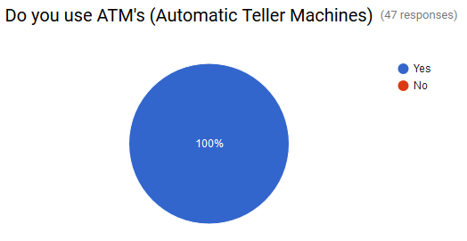

*Figure 2: Do you use ATM’s?*

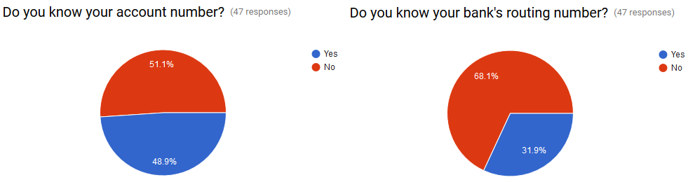

*Figure 3: Memorization of Personal Information*

# Assignment M2

Due: Sunday, October 23rd, 2016, by 11:59PM [UTC-12 (Anywhere on Earth)](https://www.timeanddate.com/time/zones/aoe). This assignment is based on lesson 3.3 (Needfinding), and focuses on executing your needfinding process.

## Assignment Instructions

Answer the following prompt in a maximum of 1200 words, with a recommended length of 1000 words; if you supply more than 1200 words, the grader will stop reading at the 1200th word, and you will not receive credit for anything written after that. You are encouraged but not required to complement your responses with diagrams, drawings, pictures, etc.; these do not count against the word limit, though any captions, text in tables, etc. does.

Execute and report the results of the needfinding exercises you outlined previously. First, for each of the three methods you selected, report the results of the exercise (~150 words each). Report the basic observations as well as your early synthesis and analysis of the data gathered within each exercise. Report also your experience controlling for the biases you anticipated previously.

Based on those observations as a whole, complete your data inventory. Answer the seven questions outlined with regard to needfinding (~350 words). For each question, specifically tie the answer to some of the observations you made throughout your needfinding exercises, and remember to keep your answers related to the problem space you defined previously. Then, define the requirements drawn out of this data inventory (~100 words). What are the requirements of your interface in terms of questions like functionalities it must provide, learnability goals it must meet, or accessibility standards it must support (as well as others)? Finally, briefly outline the next iteration of needfinding in which you might engage based solely on this initial experience (~100 words). What remaining questions are there that would benefit from additional needfinding investigation?

## Submission Instructions

Assignments should be submitted to the corresponding assignment on T-Square in accordance with the [Assignment Submission Instructions](http://omscs6750.gatech.edu/b/fall-2016/assignment-submission-instructions/). Most importantly, you should submit a single PDF for each assignment. This PDF will be ported over to Peer Feedback for peer review by your classmates. If your assignment involves things (like videos, working software prototypes, etc.) that cannot be provided in PDF, you should provide them separately (either through the class Resources folder or your own upload destination) and submit a PDF that describes how to access the assignment.

**This is an individual assignment.** Every student should submit an assignment individually.